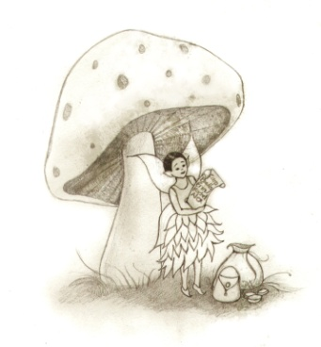
What kind of trap would you set to catch the Tooth Fairy?
Draw a picture of your trap and describe how it works.

