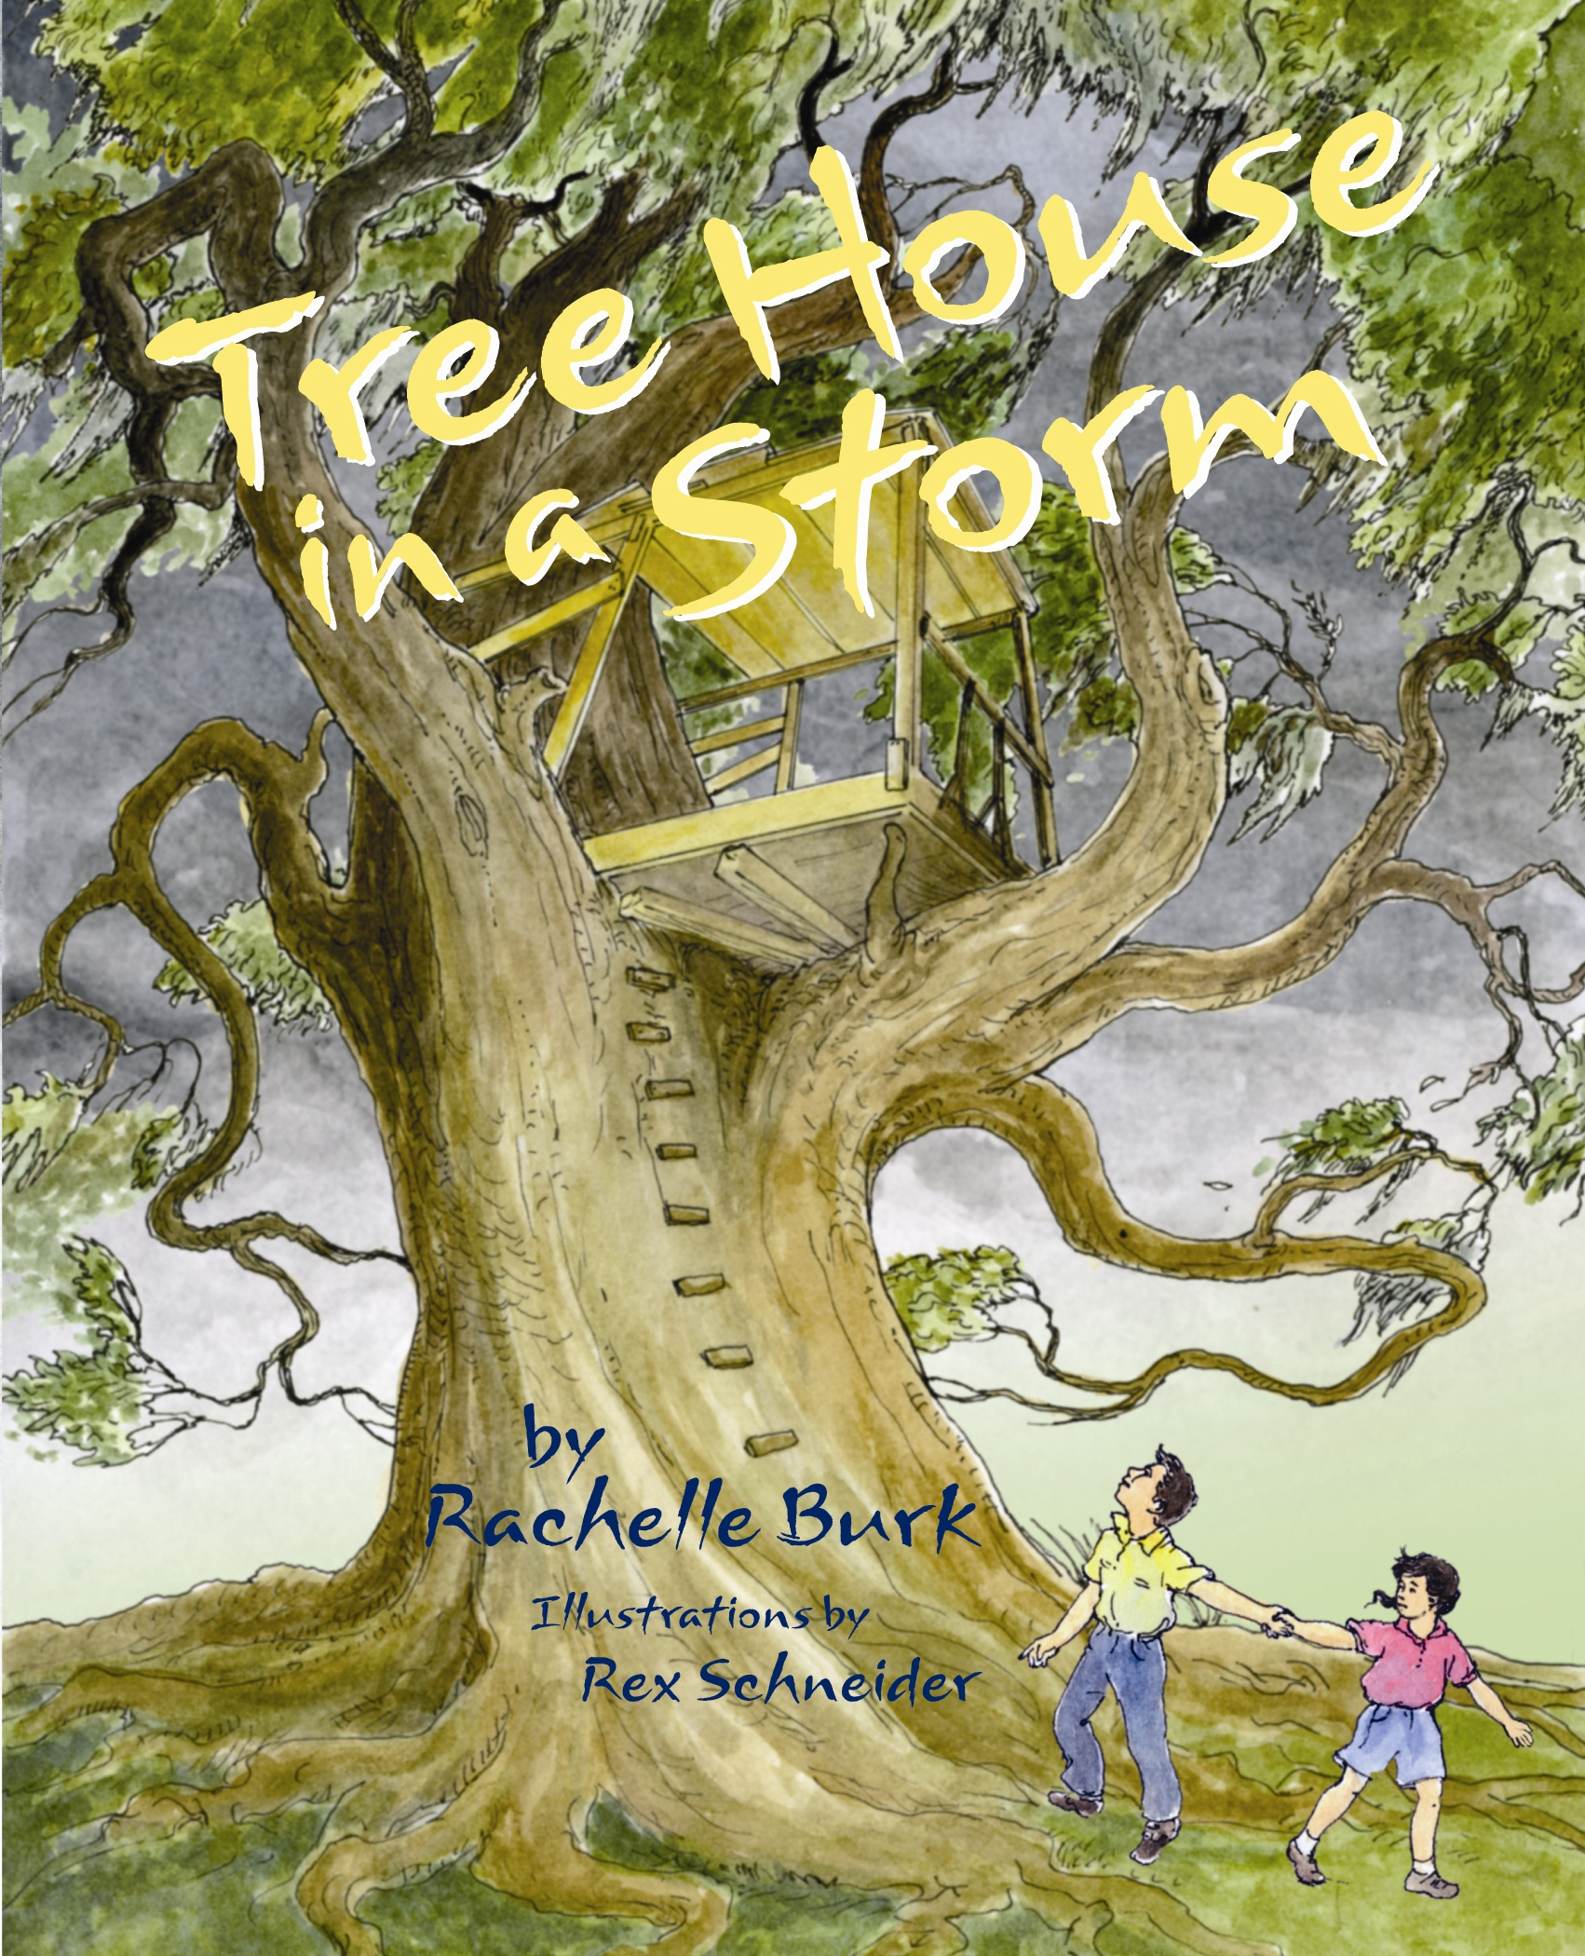
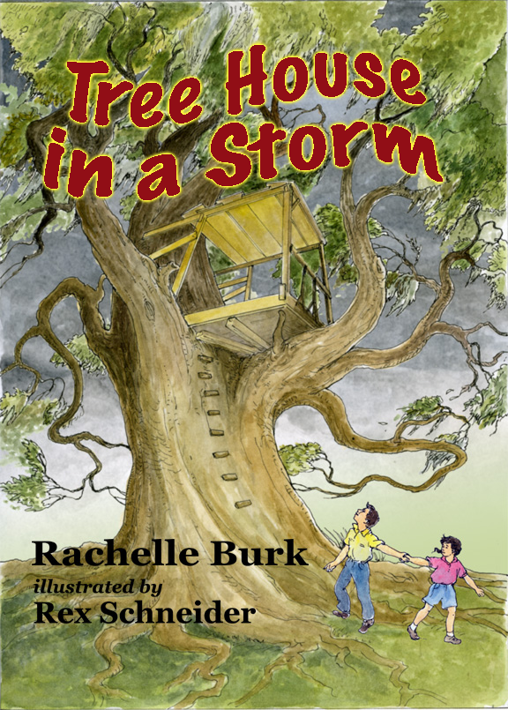 TREE HOUSE IN A STORM
By Rachelle Burk
Illustrated by Rex Schneider
Stemmer House Publishers (2009)

O O E V A C U A T E O H
N B E R N B L C S T O B
O I N R R R M U E M C A
S N A E L R O W E N E N
I P C T B H D C H K T E
L T I L E Y G B A T B B
L A R E T S N O M S U O
A K R H S S I N M I I S
D T U S Y T K A E I L R
K E H A C O E T R K D C
O D C U P R O O T S D M
F L O O D M A M C S N E

Can you find these words from the story?

ACORN ALLISON BETSY
BUILD CLIMB DREAMS
EVACUATE FLOOD HAMMER
HOME HURRICANE

MONSTER
OAK
SHELTER STORM
TREE HOUSE

UPROOT
NEW ORLEANS
KENNY
KINGDOM

