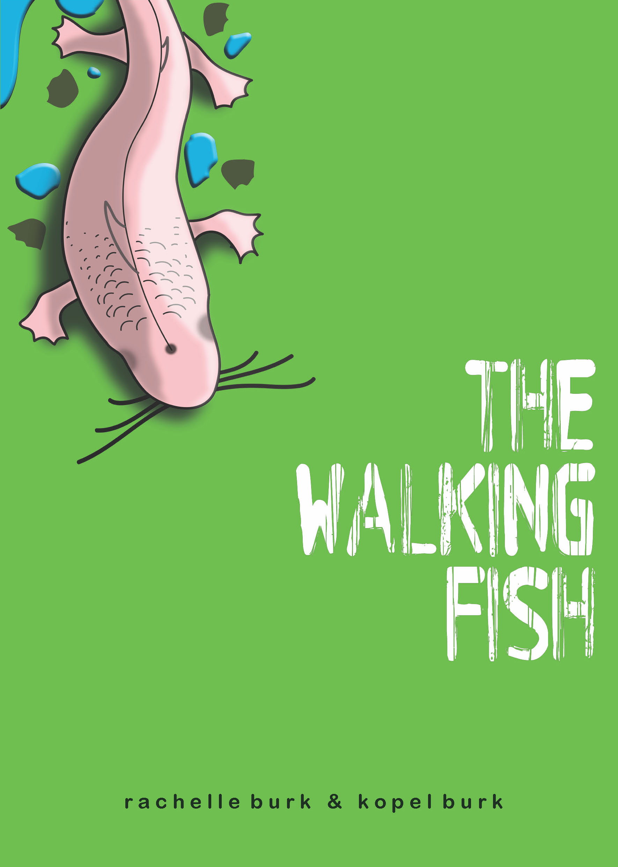
The Walking Fish
By Rachelle Burk & Kopel Burk

Age Range: 9 - 12 years
Grade Level: 4 - 7
Paperback: 192 pages
Publisher: Tumblehome Learning, Inc. (April 1, 2015)
ISBN-10: 099078293X
ISBN-13: 978-0990782933

Classroom Guide

The Walking Fish is well suited to teaching in an ELA class, a science class, or an interdisciplinary class. This document offers some possible activities and approaches, but of course teachers may have creative ideas of their own!

In the key concepts and skills listed below, the highlighted items are drawn from the fifth grade Common Core State Standards and Next Generation Science Standards.

Key concepts in English Language Arts:

Character and setting: Compare and contrast two or more characters, settings or events in a story, drawing on specific details in the text.

Conflict: Describe the motivations of characters and how these clash with other characters’ motivations to create conflict, drawing on specific details in the text.

Theme: Determine a theme of a story from details in the text, including how characters in a story respond to challenges; summarize the text.

Point of view. Describe how a narrator’s point of view influences how events are described.
Writing. Conduct short research projects that use several sources to build knowledge through investigation of different aspects of a topic.

Key Skills in English Language Arts

Participating in discussion based on evidence from the text. Cite specific textual evidence when speaking or writing about a text.

Integrating information from multiple print and digital sources.

Learning vocabulary words in context.

Key Concepts in Science – Life Science and Earth Systems

- Over time, organisms adapt to their environment, and organisms have particular structures for specific functions. (Example: How do the unusual features of the walking fish allow it to thrive in its environment?)

- Essentially all organisms on earth ultimately derive their energy from sunlight. (Example: How can we describe the food web that the walking fish is part of?)

- Earth changes over time. Water, ice, and wind move rocks and sediments around, through processes such as glaciers and erosion, and the creation of lakes and caves. (Example: How were Glacial Lake and its surrounding caves formed?)

- Water exists mostly in the ocean. Most fresh water exists in glaciers or underground, with a small fraction in lakes, streams, and rivers. (Example: Where does the water in Glacial Lake and other lakes come from? How can we track water flow in the watershed?)

Key Skills in Science and Engineering

- Engaging in argument from evidence, data, and a model. (Example: What evidence do Alexis and her friends use in trying to find the origin of the walking fish? What other evidence could they have used?)

- Use models to describe phenomena. (Example: Use a model to describe the formation of Glacial Lake or how the walking fish’s organs might allow it to function both in the water and on land.

- Obtaining, evaluating, and communicating information by combining information from books and other reliable media to explain phenomena or solutions to a design problem. (Example: How would you build a system to allow people to visit a cave without harming it? How would you build a fish tank for the walking fish, and how can you control its temperature?)

Introduction

Tell students that you will be reading a book and connecting it to science they will be learning this year. They will be reading the book as literature while also using it as a jumping-off place to read, talk, and write about science ideas.

Divide the class into groups of three or four, and tell them that each group will be responsible for researching and presenting a fifteen-minute multimedia report to the class on a science topic related to The Walking Fish. Topics may include glaciers, caves, and several unusual species of fish. They will need to draw evidence from several different sources, including books, articles on the Internet or in magazines, television shows, videos, or podcasts.

Unit 1. Chapters 1-5

A. ELA - Character development

To create an interesting and believable character, an author doesn’t just tell us what the character is like. She shows us, using several different techniques, including the following:

Physical description
How the character speaks (humor, tone, accent)
What others say about the character
What the character does (Discuss the phrase, “Actions speak louder than words.”
What the character wants (How do we know)

Have the students create a character matrix (see last page of guide). As they read, ask them to fill in the grid with showing evidence from the text of how the author creates each character. They will continue to extend this matrix as they read the rest of the book.

Extension: Ask the students to write a brief in-class essay in one character’s voice describing another, using physical description, quotations of the character’s speech, and narration of the character’s actions. For example, how would Alexis’ mother describe her? How would Darshan’s mother or Dr. Mertz describe her?

B. Science – Earth changes over time: Glaciers

Ask the students to read a short account of glaciers or glaciation in North America and compare it to the description by Alexis’ father on pages 14 – 16. Resources could be one of those listed below or books from your school or public library. Discuss the different accounts as a class. On what points do the sources agree or disagree? Which description do the students find more informative and memorable? Why? Ask for a group to volunteer to do more research and a presentation on glaciers.

http://nsidc.org/cryosphere/glaciers/questions/what.html

http://nsidc.org/cryosphere/glaciers/quickfacts.html

http://www.amazon.com/Icebergs-Glaciers-Seymour-Simon/dp/0688167055/ref=sr_1_2?s=books&ie=UTF8&qid=1425262971&sr=1-2&keywords=glaciers

Unit II. Chapters 6 -12

- ELA
- Continue to fill in the character matrix, adding in Dr. Holland and Dr. Mertz.
- Conflict.
- Conflict can arise in a story when a character wants something but barriers arise to prevent him from getting what he wants. For example, in the earlier chapters, Alexis wanted to catch a fish. Although sometimes conflict arises from natural barriers, a story is often more interesting when characters clash. Ask the students to find and discuss various instances in the book so far where characters want different things and come into conflict. What do they predict will be the major conflict between people in this book?
- Ask two students to take the parts of Alex and Dr. Mertz. Let them talk about the walking fish for a minute. Then ask each student, with help from the class, to describe the opposite character. How would Alex describe Dr. Mertz? How would Dr. Mertz describe Alex?

- Science – Structure, Function, and Adaptation of organisms

a) In what ways is the walking fish similar to or different from other fish? Help students come up with several of its key features: whiskers, blindness, pale color, feet, and a blowhole. Point them to places where they can read or see about other strange fish, such as blind desert pupfish, mudskippers, coelacanths, or the fossil fish tiktaalik. Ask students to create a chart of animals that share some features and structures with the walking fish and to discuss the similarities and differences. How have these fish adapted to their environments? What environmental conditions might the walking fish be adapted to?

Tiktaalik: https://www.youtube.com/watch?v=Du_tJo4IjGU
Coelacanth videos: http://www.bbc.co.uk/nature/life/Latimeria
Desert pupfish: http://sciences.unlv.edu/desertsurvivors/Pages/episode4.htm
Mudskipper: http://www.wimp.com/mudskipperfish/
Lungfish: http://www.animalplanet.com/tv-shows/other/videos/fooled-by-nature-lungfish/

- Ask student groups to volunteer to do a multimedia report on one of these extraordinary fish.

III. Chapter 13 - 22.

- ELA – Character and theme
- Add Gadi and Simon to the character matrix.
- Students have now read enough of the book to discuss its theme. Possible choices for a theme include scientific discovery, kids versus adults, forming an identity as a scientist, or many others. During the discussion, you might begin with asking students to summarize the action of the book so far, and then to draw on the evidence of certain episodes. How do the characters respond to challenges? For example, how does Alexis respond to the original loss of the walking fish? How does she respond to the policeman barring her from going home? How does she respond to pressure from Dr. Mertz to give up ownership of the fish? What do these episodes say about the theme?

What theme the students settle on matters much less than their ability to find evidence in the book to support their choice.

- Science – Earth changes over time: Hot springs and caves

- Hot springs: In the book, Dr. Holland’s team finds a hot spring at the depths of glacial lake. Hot springs form when water comes in contact with geothermal heat, heat that comes from the mantle deep within the earth. Hot springs can be a small trickle or a strong flow. If water emerges under great pressure, it may form a geyser.

Here is a teacher-written lesson on hot springs: http://bit.ly/1BPBxDa
One example of a lake with a very strong thermocline (change in temperature with depth) is Barracuda Lake in Palawan, the Philippines.

http://divezone.net/divesite/barracuda-lake

http://nicolekiss.blogspot.com/2013/10/barracuda-lake-thermocline-dive-in.html

Ask students to research a hot spring site, perhaps one in their state or perhaps a more famous one such as Old Faithful at Yellowstone. This could be a subject of a report by one group.

- Cave formation: Caves are fascinating and mysterious. They form when acidic rainwater eats away at rocks that can dissolve, such as limestone or gypsum. Here is one short explanation: http://bit.ly/1F1bsOJ

Here is a short animation of cave formation. http://bit.ly/1iRDofJ Ask students to write a brief in-class description of how the caves above Glacial Lake may have formed. Where did the limestone in the caves come from? They can refer back to page 14 of the book.

IV. Chapters 23 – 30.

- ELA – Structure of a novel

- Discuss with students the structure of a novel, with gradually rising action until the climax, which is followed by falling action as the story’s loose ends are tied up. Ask them to chart the rising action, climax, and falling action of The Walking Fish. How does everything that goes before lead to the climax?

- In some works of fiction we can talk about an action climax and an emotional climax. That is, sometimes the main character can have a personal realization that comes before or after the climax in action. Alexis realizes in chapter 29 that the way she has been using Darshan for her own glory makes her not that different from Dr. Mertz. Guide the students to discover and discuss this moment of change for Alexis. As with the action climax in the cave, challenge them to find evidence of the events leading to this emotional turning point.

- If you would like to ask students to do a final writing exercise for this book, some possibilities might include:

- narrating a section of the action in the voice of a different character
- analyzing what the walking fish means to different characters
- discussing what Alexis learns about being a scientist
- discussing how Alexis or another character changes over the course of the book.

- Science – Adaptation of organisms.

- Various organisms adapt to cave life. Here is a slideshow of ten odd cave-living creatures: http://bit.ly/1F1bsOJ
What adaptations have these creatures made to cave living? How has the walking fish adapted to cave living?

- Food webs. Essentially all organisms on earth ultimately derive their energy from sunlight. How does the walking fish get its energy? Does this derive from sunlight even though it lives in the dark? (plants-insects-bats- bat droppings- fish-decomposers)
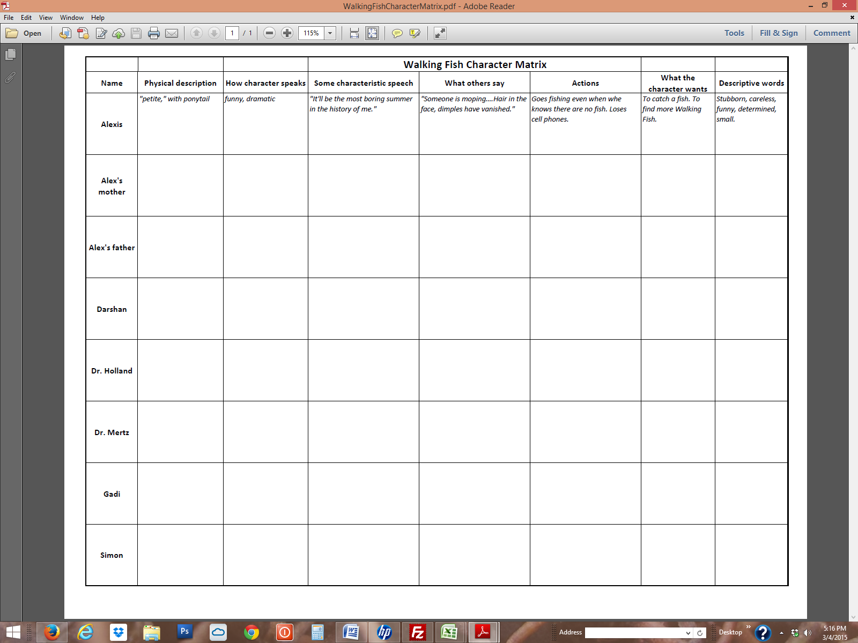
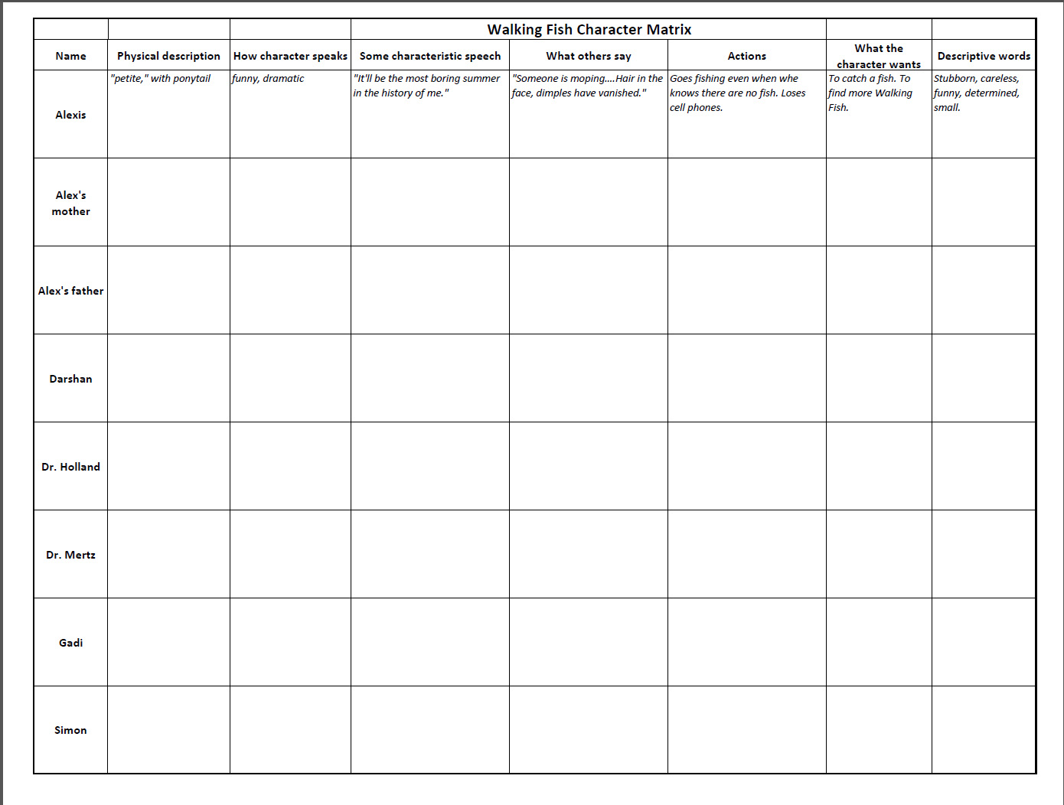
3. The course of a scientific investigation. Ask students to describe or write a short essay on the steps that Dr. Holland and his team took to find the original habitat of the walking fish? (Exploring the depths of the lake, looking for bodies of water in caves, dyeing the cave water to find out where they drain, examining cave soil). What unexpected discoveries did they make along the way? (Hot spring at the depth of Glacial Lake.) What clues did Alex find about the source of the fish? (Water in the side passage, cold water flowing into the pond by her house, dye.)

4. If there are any remaining groups that have not chosen a report topic, ask them to prepare a presentation on one or more cave organisms.

Vocabulary – Ask students, working in teams to deduce the meaning of these words from context before splitting up the task of looking up the words and sharing their official meaning. Then challenge the students to use the words in class discussions and writing, perhaps giving students a point for each time they use one.

flounder (noun & verb) – p.1
stock (verb) – p. 3
mope – p. 4
lure – p. 7
continental shelf – p. 14
igneous – p. 15
smirk – p. 21
alien – p. 21
serenity – p. 23
hover – p. 32
appendage – p. 32
hunch – p. 33
deploy – p. 33
theorize – p. 33
translucent – p. 34
hypothesis – p. 39
pH – p. 42
extinct – p. 46
filter, filtration – p. 48
surly – p. 62
horde – p. 70
gaggle – p. 72
gawk – p. 76
sonar – p. 83
geothermal – p. 87

fault – p. 87
melodramatic – p. 89
spelunking – p. 92
claustrophobic – p. 94
archives – p. 96
rappel – p. 103
hypothermia – p. 106
foyer – p. 108
humiliation – p. 110
stalactites – p. 112
stalagmites – p. 112
eerie – p. 113
fracture – p. 113
sediment – p. 114
biodegradable – p. 123
procrastination – p. 128
swig – p. 132
artery – p. 134
rabid – p. 135
exasperation – p. 143
rhetorical question – p. 151
credibility – p. 155
obsess – p. 159
parole – p. 167
rudimentary – p. 170

