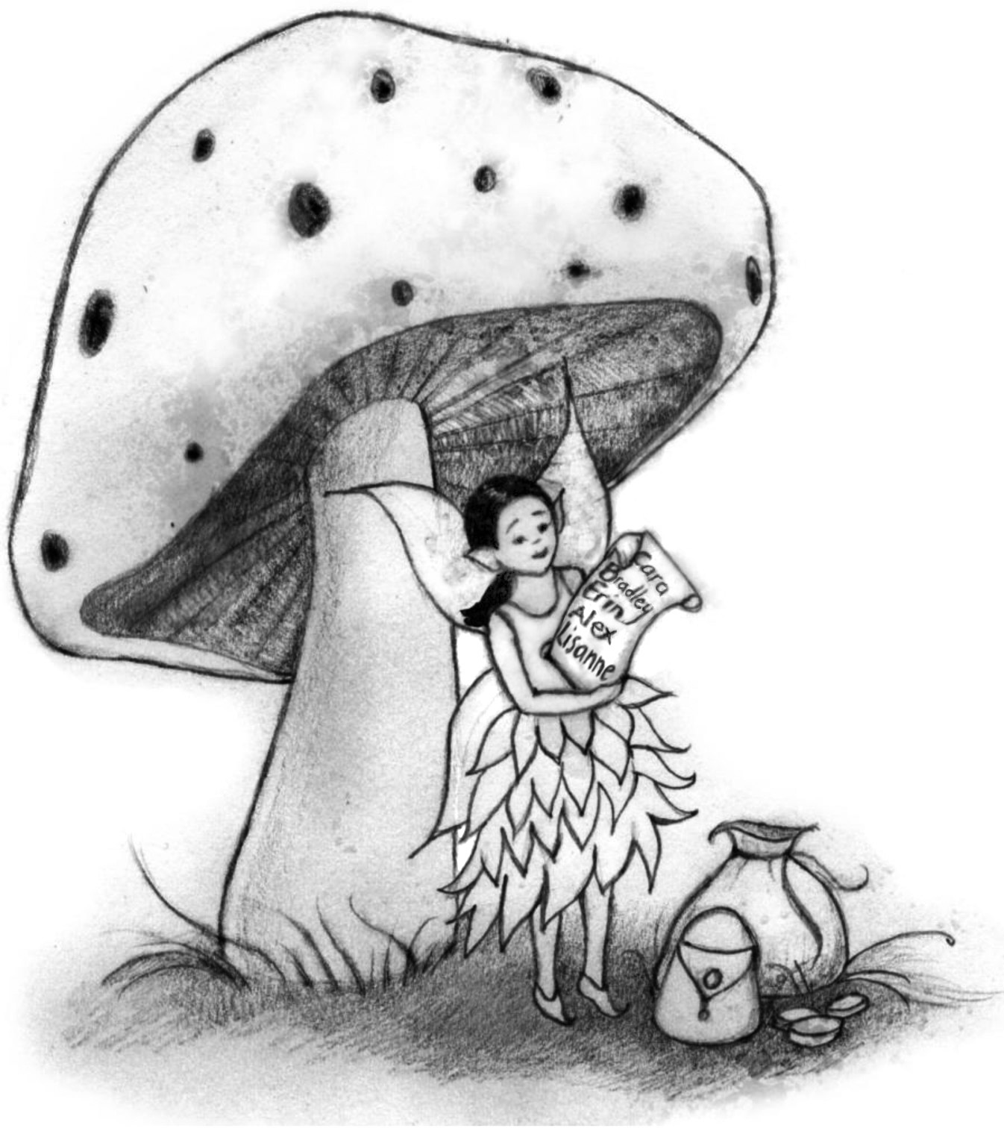
Tooth Fairy Trap: School Trivia!

Here are the rules:

- Two trivia questions will be read over the loudspeaker each day.
- Classes will have until 3:00 pm that day to send their answers to (librarian?), either by sending down a written/typed/printed paper or by sending an email.
- All correct answers will be placed in a daily prize raffle drawing for: (ex: a classroom gift certificate to the Scholastic Book Fair, pizza party, etc).
- Each morning, one homeroom from K, 1st, and 2nd grades will be selected from the correct answers of the previous day .
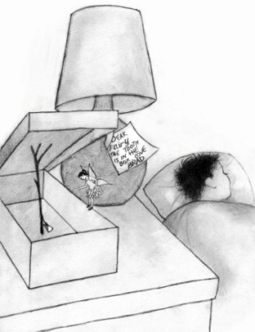
- The daily trivia questions will be listed below for your reference.

Friday
- What is Bluma’s allergy? (chapter 1)
- When does Faylene tell Bluma to be home by? (chapter 1)
- Why is Bluma not happy about visiting Bradley’s room? (chapter 2)

Monday
- Where did Erin hide her tooth the last time Bluma visited? (chapter 3)
- What happens if a tooth fairy leaves money for a fake tooth? (chapter 4)

Tuesday
- What food does the hamster REALLLLLLY want? (chapter 5)
- How are Cara and her doll Katie the same? How are they different? (chapter 6)
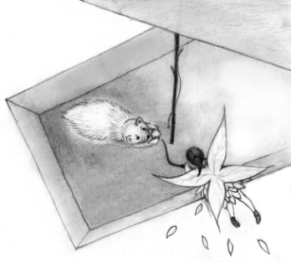
- How does Bluma know she’ll be back to visit Cara soon? (chapter 6)

Wednesday
- How is Bluma able to give Sheba a full-sized bone? (chapter 7)
- Why isn’t Bluma able to put money under Bradley’s pillow (chapter 8)
- Of what material is Bluma’s dress made? (chapter 8)

Thursday
- What does Bluma use to brush her teeth? (chapter 9)
- What three things did Bluma use to make sure her night was a success? (chapter 9)

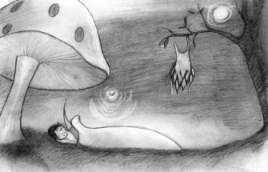
FRIDAY: Award day!

Thanks to Theresa Wordelmann, who created this trivia activity while using The Tooth Fairy Trap as part of Jeffrey Clark School’s One School/One Book program, spring 2017.

