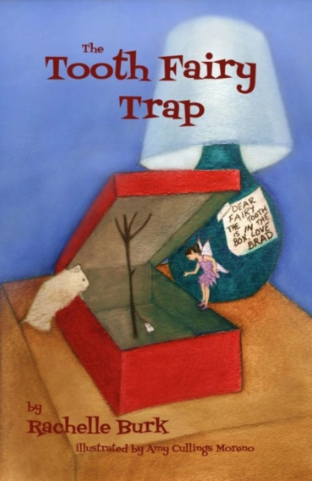
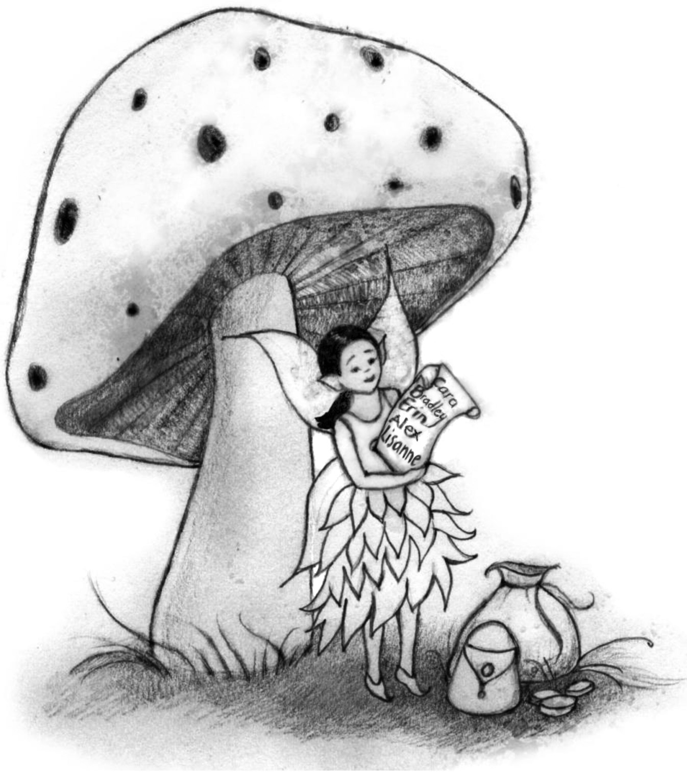
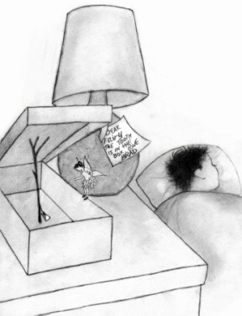

The Tooth Fairy Trap
Chap. book for grades K-2
Comprehension guide / Trivia Questions

- What is Bluma’s allergy? (Chap. 1)
- When does Faylene tell Bluma to be home by? (Chap. 1)
- Why is Bluma not happy about visiting Bradley’s room? (Chap. 2)
- Where did Erin hide her tooth the last time Bluma visited? (Chap. 3)
- What happens if a tooth fairy leaves money for a fake tooth? (Chap. 4)
- What food does the hamster REALLLLLLY want? (Chap. 5)
- How are Cara and her doll Katie the same? How are they different? (Chap. 6)
- How does Bluma know she’ll be back to visit Cara soon? (Chap. 6)
- How is Bluma able to give Sheba a full-sized bone? (Chap. 7)
- Why isn’t Bluma able to put money under Bradley’s pillow (Chap. 8)
- Of what material is Bluma’s dress made? (Chap. 8)
- What does Bluma use to brush her teeth? (Chap. 9)
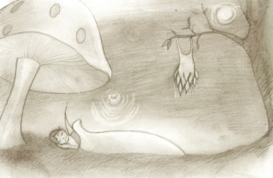
- What three things did Bluma use to make sure her night was a success? (Chap. 9)

Thanks to Theresa Wordelmann of Jeffrey Clark School, who created this as
a trivia activity as part of the One School/One Book program.

