TOOTH FAIRY JOB APPLICATION
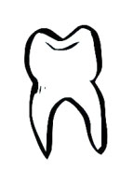
NAME:_______________________________________

WHY DO YOU WANT TO BE A TOOTH FAIRY?
_________________________________________________________________________________________________________________________________________________________________________________________________

WHY WILL YOU MAKE A GOOD TOOTH FAIRY?
1.____________________________________________________________________________2.___________________________________________________________________________

WHAT WILL YOU DO WITH ALL THE TEETH YOU COLLECT?
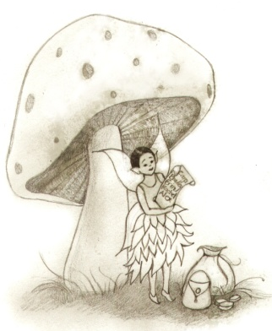
_______________________________________________________________________ ________________________________

CAN YOU FLY?
Circle One: YES or NO

