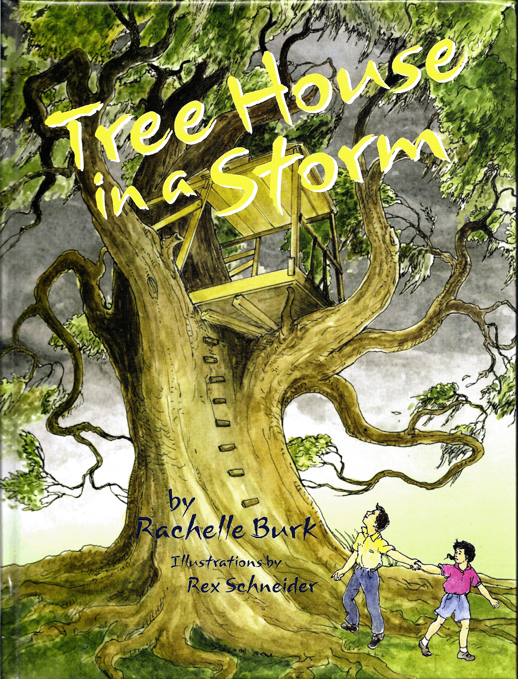
A Teacher’s Guide to
TREE HOUSE IN A STORM
Rachelle Burk
Illustrated by Rex Schneider
Stemmer House Publishers
42 pages
For Ages 5-10
Book Summary:
Kenny and his sister Allison build a tree house where they play and imagine all summer long. Then, that fall of 1965, Hurricane Betsy blows into the city. While their parents hurry to secure their home, Kenny does what he can to protect the tree house. The family evacuates to a shelter to wait out the storm. But in spite of his efforts, Kenny and Allison’s beloved tree house becomes one of Hurricane Betsy’s victims. How will Kenny and Allison deal with their loss, and what do they do to rebuild their dreams?

This book offers high appeal content with meaningful artwork for primary school children. It serves as an effective discussion tool for the classroom, as it explores natural disaster and loss as topics of universal theme.

The Author:
Rachelle Burk grew up in New Orleans, Louisiana. She lived through Hurricane Betsy as well as other hurricanes. She is a social worker, a clown, a storyteller, and school presenter. Rachelle’s works include picture books, chapter books, and a middle grade novel. She also has published stories in such popular children’s magazines as Highlights for Children and Scholastic Science World. Read more about the author at www.RachelleBurk.com

The Illustrator:
Rex Schneider lives in Gobles, Michigan and has illustrated numerous books for children. His work has also appeared in magazines such as Cricket, Ladybug, Spider, and Highlights for Children. He used watercolor to paint the illustrations for Tree House in a Storm, and also is the illustrator for Rachelle’s chapter book, Miss Crump’s Funny Bone.. Learn more about the illustrator at www.bluemousestudio.com

Tree House in a Storm Teacher’s Guide—Page 2
Teaching Ideas:

Before Reading the Book: Questions and Activities
- Locate New Orleans on the map.
- Ask students to share what they know about Hurricanes. How do they differ from other storms?
- When is hurricane ‘season’?
- Show students pictures of hurricane damage. Ask to describe what hurricanes can do.

Post-Reading Discussion Questions and Writing Activities:
About the book:
- How did Kenny and his family know a hurricane was coming? How did the family prepare?
- Why did they leave their homes? What might have happened had they stayed?
- Could Kenny have done anything to save his tree house?
- How might the family and others like them help those who weren’t as lucky?
- Why did Kenny feel lucky, even when he was sad?
- Does the book reveal who is telling the story?
- How do you think the grown-up Kenny and Allison feel about being in the new tree house, and why?

Universal themes within the book:
- What does the term “natural disaster” mean?
- What disasters have you heard about in the news, such as hurricanes, tornados, earthquakes, tsunamis, or fires?
- What kind of natural disasters occur where we live? How can we prepare?
- How can we help victims of hurricanes and other natural disasters after they’ve lost homes and belongings?
- Have you ever lost anything you love? How did you (or would you) deal with it?

Tree House in a Storm Teacher’s Guide—Page 3
Grammar and Vocabulary:

Define the words: * Binoculars * Tantrum * Ogre * Evacuate *

Chart the Story:
- On the board, create three columns labeled “Beginning” “Middle” and “Ending.” Ask students what happened in the beginning of the story and record answer in the first column, (e.g. Kenny and Allison build a tree house.) Repeat with the middle and ending. Allow students to take turns illustrating scenes or picture from the beginning, middle and ending of the story, on the story map.
- On the board, create five columns. Label the columns: Characters, Setting, Problem, Events, and Ending. Discuss each element and record ideas about them in each column.

Creative Activities:

Grades K-1:
- Take students for a walk around the school. Look for trees that could hold a tree house and ask how they would build it. Why are some trees too small or others too tall? What would you do in your tree house? How would you stay safe in your tree house?
- Draw a picture of your tree house.
- Did you notice that there are frogs hidden in most of the pictures? See how many you can find!

Grades 2-6:
- Design your own tree house (individually or as a class).
- Write a story about what you would do in your tree house.
- Write about something special that belongs to you, and how you would feel if you lost it.
- Write about how you would keep your home safe in a hurricane, and how you would prepare.

Tree House in a Storm Teacher’s Guide—Page 4
Extensions:

- Create a timeline for Tree House in a Storm: List the events in the story. Decide on a starting time for the first event. (built tree in early summer) Use clues from the story to guess how much time passes from event to event and chart the timeline. This activity can be done as a whole class activity with K-1 students. Students in 2-5 will be able to list the events and decide on a starting point as a whole group, then work independently or in small groups to finish the timeline.
Example:
June 15, 1965—Kenny and Allison begin to build a tree house
June 30—Children complete the tree house
July-Sept.—The children play in tree house
Sept. 9–Hurricane Betsy hits New Orleans
…and so on as Kenny plants acorn, grows up, marries, has children, and helps them build a tree house of their own.

- What kind of natural disasters occur in your part of the country? Check out FEMA or Red Cross websites below and develop an emergency plan.
- How can we help victims of hurricanes and other natural disasters (including fires), after they’ve lost homes and belongings? Plan an aid drive to send needed money or items.

Books and websites about hurricanes:
- Hurricanes by Seymour Simon. Collins Publishing, 2007
- The Magic School Bus: Inside A Hurricane (Magic School Bus), by Joanna Cole
- Yesterday We Had a Hurricane, by Deirdre McLaughlin Mercier
- Hurricane Katrina and New Orleans- An Educational Therapeutic Story, Coloring and Workbook by Benjamin Jackson and Doris Jackson
- National Hurricane Center of the National Weather Service: Includes hurricane history, current storm information, hurricane preparedness, and more: http://www.nhc.noaa.gov/

Tree House in a Storm Teacher’s Guide—Page 5

Websites about disaster preparation:
- FEMA (Federal Emergency Management Agency): FEMA has a website for kids: They can learn how to prepare for all kinds of disasters, and can order posters, videos and other fun things for free: http://www.fema.gov/kids/
- American Red Cross: www.redcross.org
- Ready America (U.S. Department of Homeland Security, Emergency Preparedness): http://www.ready.gov

Photo books about tree houses:
- Treehouses of the World by Pete Nelson (Author) and Radek Kurzaj (Photographer)
- The Treehouse Book by Peter Nelson and Judy Nelson

