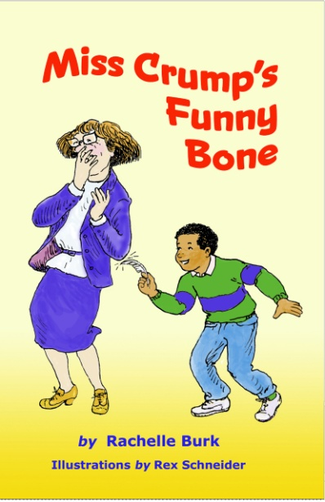

Miss Crump’s Funny Bone

By Rachelle Burk
Chapter book for grades 2-4

Comprehension Guide / Trivia questions

- What is Frankie’s motivation for participating in the dare? (p.22)
- What was Lovey’s motivation for joining the dare? (p.22)
- What are some differences between Mr. Greenberg’s classroom and Miss Crump’s? (p.2)
- What is the pet gerbil’s name in Mr. Greenberg’s class? (p.6)
- What is the winner’s prize? What does the loser get? (p.23)
- What sweet thing does Alana smell like? (p.14)
- What is Lovey’s real name? How did she get her nickname? (p.18)
- What is Frankie’s real name? (p.21)
- What does Lovey want to be when she grows up? (p.22)
- What does Alana most enjoy reading? (p.22)
- Why is 6 afraid of 7? (p.35)
- What two signs indicate that Miss Crump is annoyed? (p.35 & 37)
- What is Miss Crump’s worst habit? (p.37)
- What happens to Jeffrey when he fails to make Miss Crump laugh? (p.51)
- How does Mr. Kropp, the principal, celebrate monthly Library Day? (p.52)
- In what contest does Jeffrey and Mr. Kropp compete? (p.55)
- What is Lovey’s record in a “tickle war”? (p.60)
- What is the title of Frankie’s cartoon? (p.62)
- What is the funniest thing Frankie ever saw? (p.66)
- How many forehead wrinkles did each child give Miss Crump? (pp.35, 52, 70, 77)

Discussion Questions

- Do you think Jerry bullies Frankie into participating against his will?
- Screen What are the pros and cons of participating in the dare?
- What does it mean to “tickle someone’s funny bone”?
- If you had been part of the dare and did not know what would make Miss Crump laugh, what do you think you would have tried?
- What makes you laugh?
- What is the funniest thing you’ve ever seen?
- Tell a funny joke that you’ve heard.
- Make up a joke!

