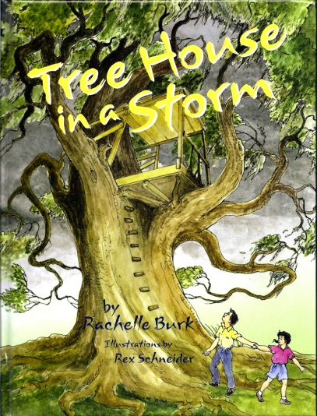
Lunch With The Author Contest

Would you like to have lunch with our visiting author? Our contest is a creative writing project based on Rachelle Burk’s book, Tree House in a Storm.

Here’s what you need to do!

- Create, design, and draw a tree house. Use the “draw-a-tree-house” form provided, or create one completely on your own on white paper.

- Write a sentence or two (K-1st), story or description (2nd-5th) about your tree house. Some ideas of what to include in your story:

Who do you let come up into your tree house?
What do you have in your tree house?
What do you do there?
What adventures do you have?
What can you see from your tree house?

- Use lined paper your teacher has for the project, or you can use a computer to create and tyupe your story.
- Attach the story to the picture of your tree house.

BE CREATIVE! BE NEAT! Check spelling and punctuation. (Write a sloppy copy first, then turn in your final copy.)

***Put your name and your teacher’s name on the back of your project***
Projects will be judged on your story’s content, creativity, and neatness.

ALL CONTEST ENTRIES MUST BE TURNED IN TO YOUR TEACHER BY:____________________

