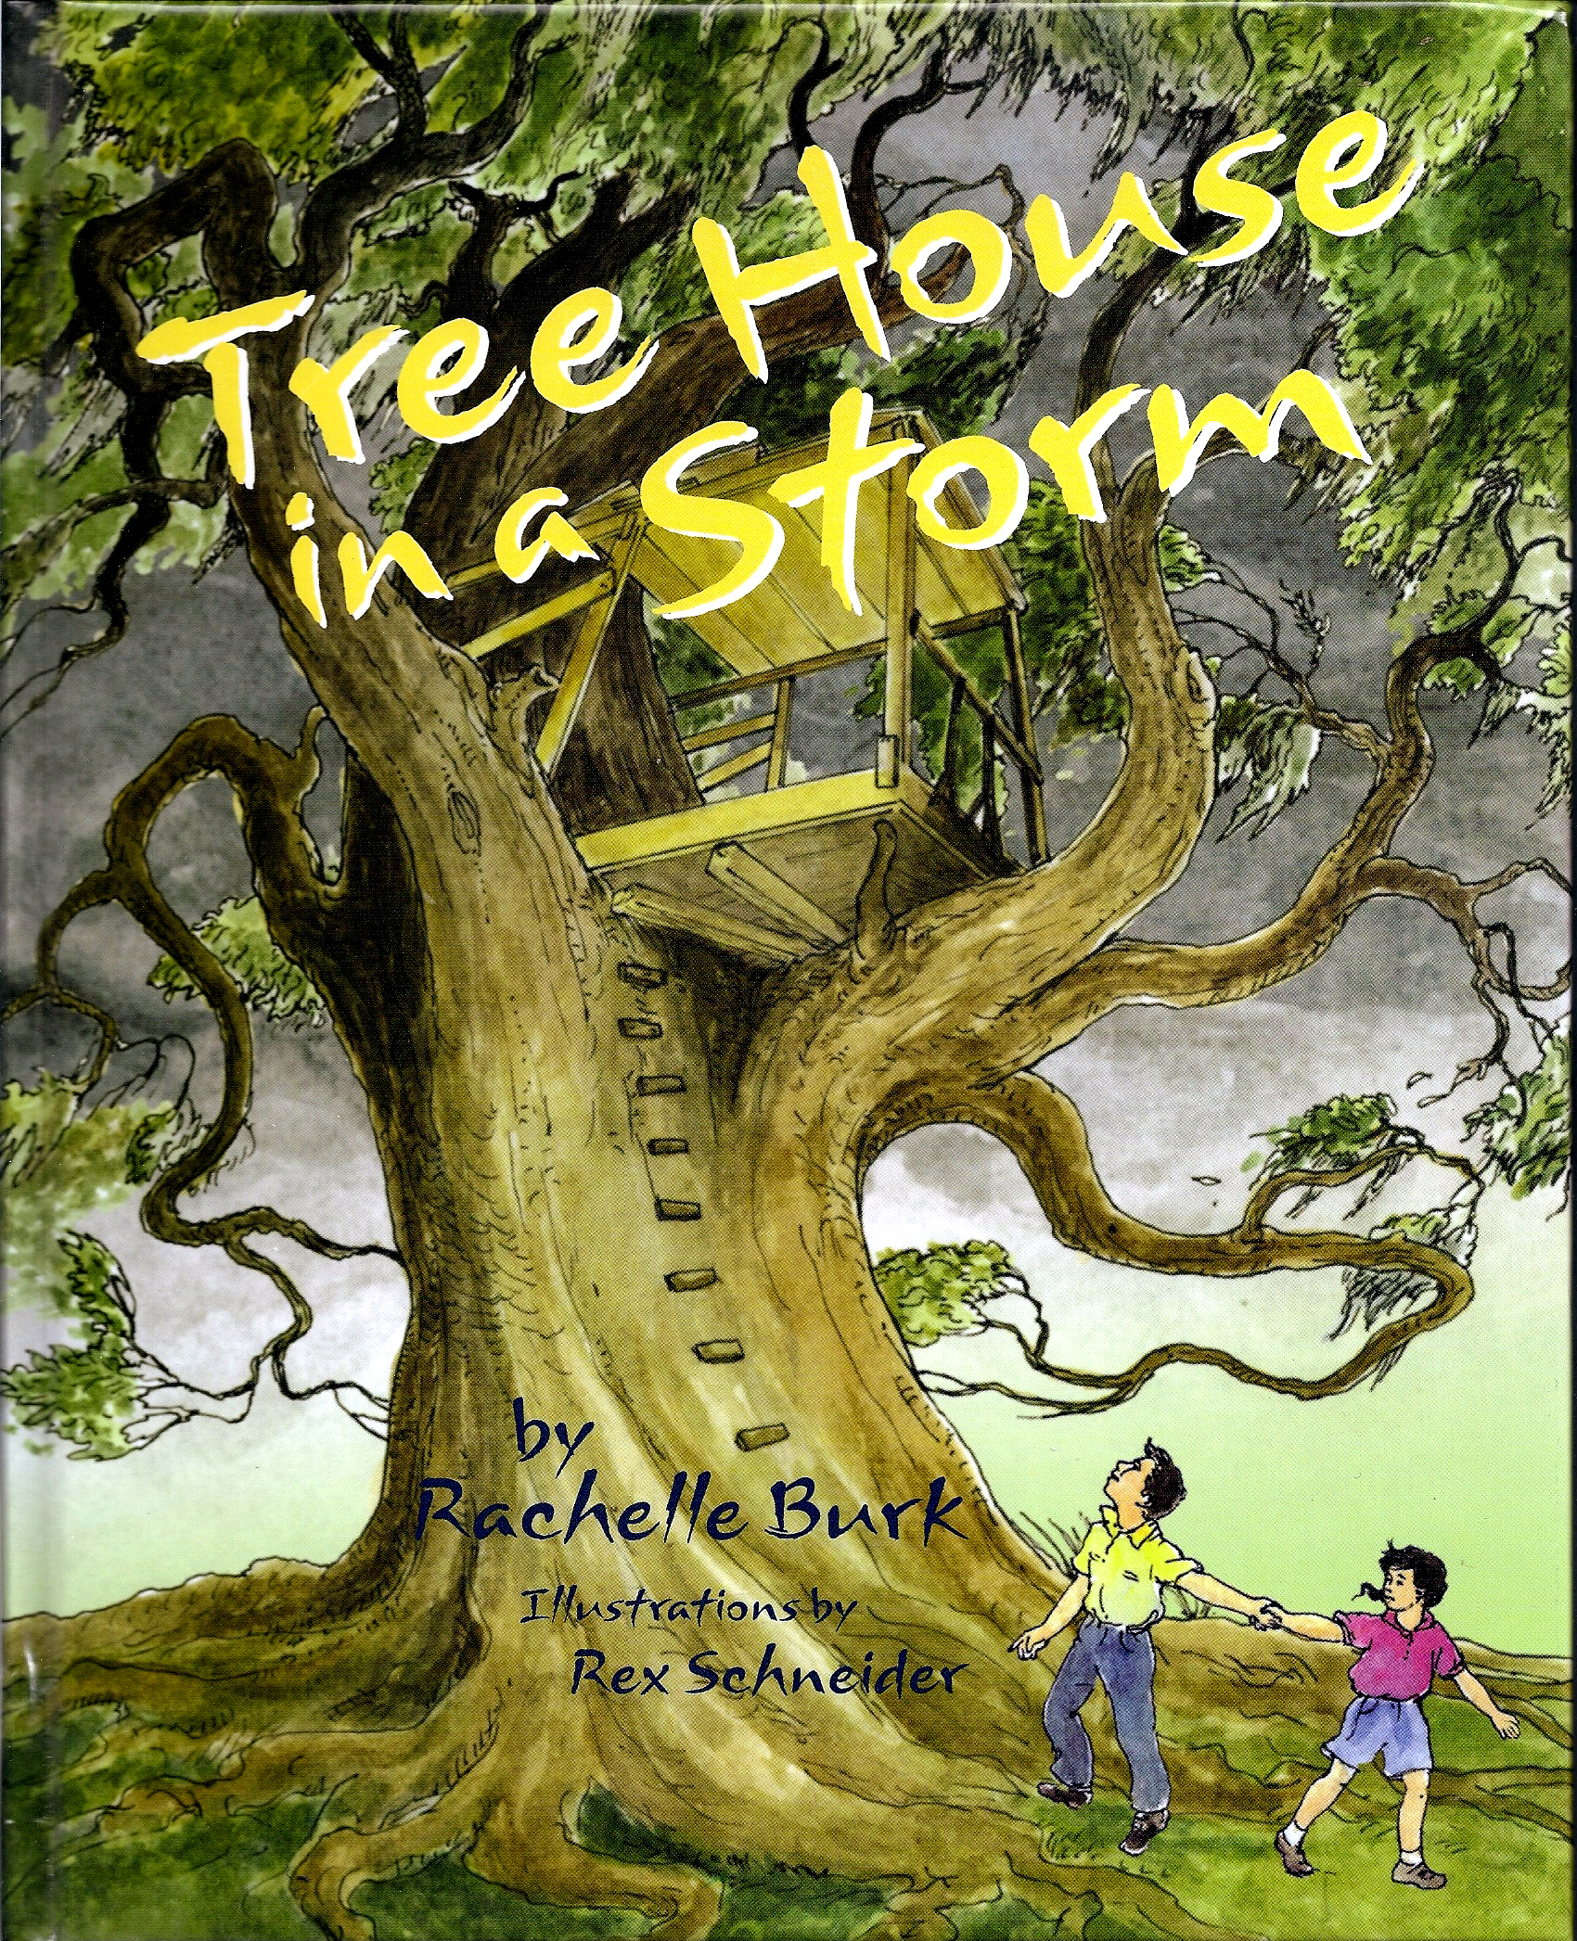
TREE HOUSE IN A STORM
By Rachelle Burk

FIND THESE WORDS FROM THE STORY


Across
1. Helps you see very far
2. Leave home for a safer place
5. Noise heard in a storm
7. Hot season
9. Seed from an oak tree
11. A safe place to be in a hurricane
16. Small bird
19. Sometimes appears after a storm
20. A city in Louisiana

Down
1. Limbs of a tree
3. Peanut butter & __ sandwich
4. Lights up stormy skies
6. Flat wood used to build a tree house
8. Biting bug that makes you itch
10. Kenny’s sister
12. Type of cool citrus drink
13. River that flows through New Orleans
14. Big storm with strong winds
15. Twisted (like tree roots)
17. Strong buildings are made of this
18. Our galaxy

