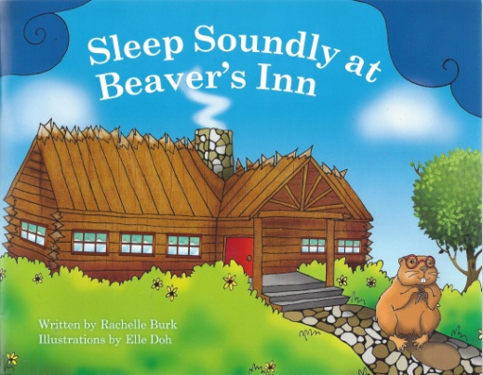

Class guide to
Sleep Soundly at Beaver’s Inn

- Onomatopoeia is the naming of a sound by trying to imitate it, as in "meow" (The cat meowed) or "boom" (The thunder boomed). Can you find examples of onomatopoeia in the story? (A: tippity tappity, whoo whoo, splish-splosh, chicka chicka)
- Alliteration happens when words that start with the same sound are used close together in a phrase or sentence. It makes a catchy sound that’s fun to say and easy to remember. Examples are “Mickey Mouse” and “Pokey Little Puppy”. Can you find examples of alliteration in the story? (A: rhythm of the rain, song of the surf, whistle of the wind)
- A metaphor is a word or phrase that is used to make a comparison between two people, things, animals, or places. Rat calls the waves “the song of the surf.” In what way is this a metaphor? Can you make up some metaphors of your own?
- Multiple meaning of title? What does “sound sleep” typically mean? (sound advice) What is the secondary meaning of the title?
Reading comprehension
- Why do guests go to Beaver’s Inn?
- What is it about Jackrabbit that makes him want to be active when the others want to sleep? (Discuss nocturnal vs diurnal animals).
- Why is Jackrabbit afraid when he first hears the sound?
Animal Info--research
- In the story, Toad comes from the rainforest, Eagle from the mountain top, Rat from a ship on the sea, Jackrabbit from the desert. Where else can each of these animals be animals found?
Make the instruments in the story, and more! Visit the author’s web page:
http://rachelleburk-authorvisits.blogspot.com/p/sleep-soundly-at-beavers-inn.html

