ADVANCE ORDER BOOK LIST FOR
SCHOOL TEACHERS AND LIBRARIANS
ORDER BY EMAIL: rachelleburk@gmail.com
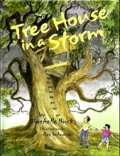

Tree House in a Storm (Soft Cover picture book)
When Hurricane Betsy roars through the city, what will happen to Kenny and Allison's tree house? A happy-ending story of hope and rebuilding.
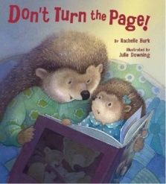
Don't Turn the Page! (HARD Cover picture book)
Sami puts bedtime as long as possible. But reading a book about Little Bear's bedtime inspires Sami, just as the reader will be inspired by this clever book-within-a-book concept with a surprise ending.
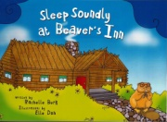
Sleep Soundly at Beaver’s Inn (Picture book early reader)
Animals arrive from the rainforest, mountain, sea, and desert to stay at Beaver's Inn. When they can't sleep, his homemade instruments create sounds that soothe his guests to sleep. All except for one… (Paperback)
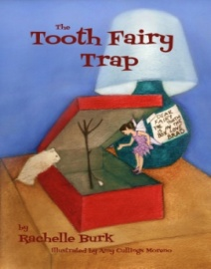
The Tooth Fairy Trap (Early Chapter Book)
A nervous Tooth Fairy (who is allergic fairy dust) has adventures in each room she visits, but her biggest challenge is Brad’s fairy trap. She can only succeed in collecting his tooth with the help of the boy’s grouchy hamster, and a few things she has gathered throughout the night. (Paperback)
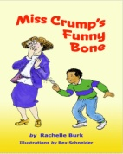
Miss Crump’s Funny Bone (Chapter Book)
Frankie and two classmates bet on who can get their third grade teacher, "Grumpy Crumpy," to laugh. You’ll laugh too, as they race to discover what can tickle Miss Crump's funny bone! (Paperback)

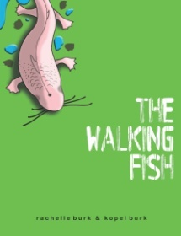
The Walking Fish (Science-Adventure Novel— National Science Teachers Association award winner)
A humorous, exciting tale of an ordinary child who makes an extraordinary scientific discovery—a blind fish that walks! With great settings, vivid characters, and at times hilarious, this book presents the adventure of science in a way that’s sure to appeal to girls and boys in grades 4-7. Available in both hardcover and paperback

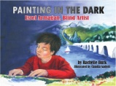
Painting in the Dark: Esref Armagan, Blind Artist (Soft Cover—Nonfiction picture book) The mind-boggling true story of a world-famous painter born totally blind. How does he do it, and why? Fascinating and inspiring for both children and adults. Grades 3 and up. Available in both hardcover and paperback

TITLE PRICE No. of COPIES Total
TREE HOUSE IN A STORM (paperback) $10 x ______ = $_________

___________________________________________________________________________________________________________
DON'T TURN THE PAGE! (hardcover ) $12 x _______ = $_________

___________________________________________________________________________________________________________
SLEEP SOUNDLY at BEAVER’S INN (paperback) $8 x _______ = $_________

___________________________________________________________________________________________________________
THE TOOTH FAIRY TRAP (paperback) $8 x _______ = $_________

___________________________________________________________________________________________________________
MISS CRUMP’S FUNNY BONE (paperback) $8 x _______ = $_________

___________________________________________________________________________________________________________
THE WALKING FISH (paperback) $8 x _______ = $_________
(hardcover ) $12 x _______ = $_________
________________________________________________________________________________________________
PAINTING IN THE DARK (paperback) $10 x _______ = $_________
(hardcover ) $14 x _______ = $__________
____________________________________________________________________________________________________

total for all books $ _________

For classroom activities related to the above titles, visit www.RachelleBurk.com,
and click on the cover images.

