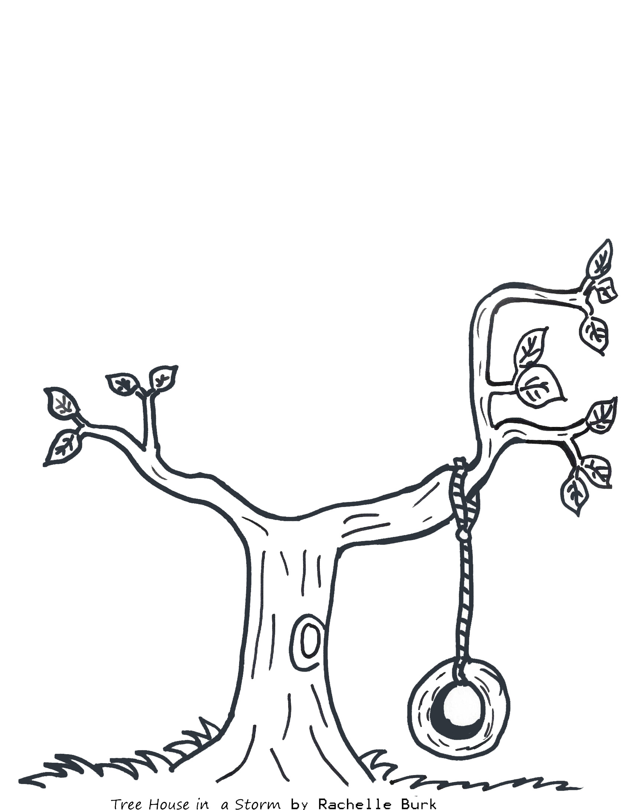

***Build Your Own Tree House!***